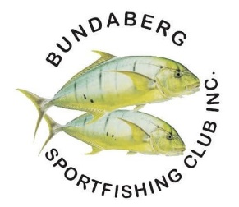
BUNDABERG FISHING FESTIVAL 2024
REGISTRATION FORM
The 2024 Fishing Festival is to be hosted by the Bundaberg Sportfishing club. The ANSA QLD Fishing Festival is a wonderful event where all ANSA members, along with their families and friends can gather and enjoy a social long weekend catching up, a friendly fishing competition, formal dinner with the Annual Awards and the AGM.
To register for this event, you will need to complete the form below and return to ANSA QLD and pay your entry fee.
Adult (16+): ANSA Member – $45.00 Kids (5-15yrs): ANSA Member – $20.00
Adult (16+): Non-member – $75.00 Kids (5-15yrs): Non-ANSA Member – $40
Kids under 5 FREE
Name | Mobile | Email | Club | Category  Senior/Junior | Amount
 |  |  |  |  | $
 |  |  |  |  | $
 |  |  |  |  | $
 |  |  |  |  | $
 |  |  |  |  | $
 |  |  | Total Amount to be paid |  | $
Please complete the form and send to: treasurer.ansaqld@outlook.com.au
You can pay your Festival registration via Bank Transfer.
BSB: 034-073 ACC#: 314049 Reference- Your name
Receipt will be sent once are funds received.

\While ANSA QLD takes all due care when conducting events, by registering for this event, you have agreed that ANSA QLD are not liable for any damage, injury or costs sustained to persons or property, therefore all persons participating in ANSA QLD events must conduct themselves in a responsible manner. ANSA QLD Inc reserves the right to cancel their entry, alter any competition rules or alter event venues. Please be aware, that fishing photographs taken may be used on the ANSA QLD website, social platforms and future event advertising.

